**ASSIGNMENT-2**

Create a New Facebook Business Page and Post one social media poster for your brand.

|  |  |
| --- | --- |
| NAME | S.SATHISH |
| NM ID | D3AB4E60998F2BBA802428A0FF7D9B00 |
| ASSIGNMENT 2 | Create a New Facebook Business Page and Post one social media poster for your brand |

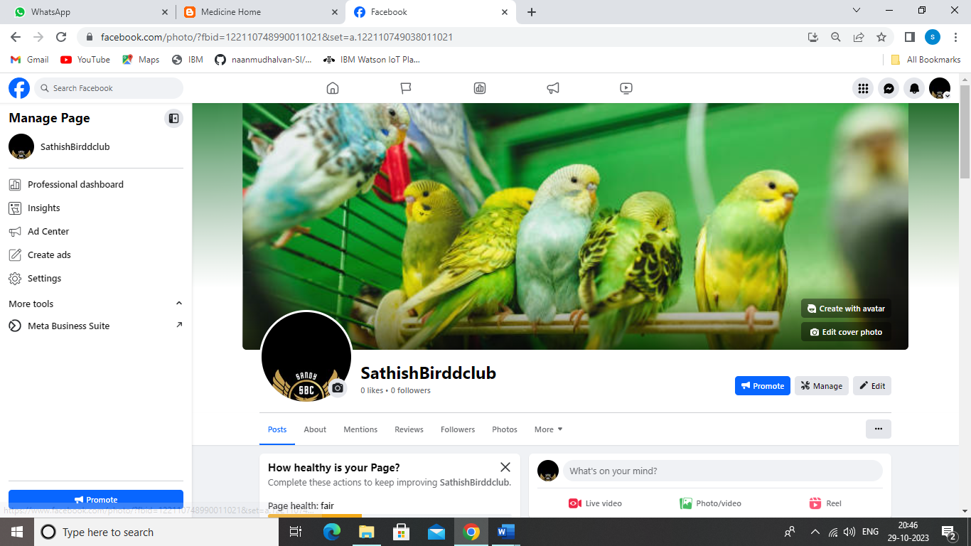

**FACEBOOK PAGE LINK:**

<https://www.facebook.com/sathishbirdclub>